**FBISD School Health Advisory Council (SHAC)**

**Vision:** The FBISD School Health Advisory Council (SHAC) was established by the Board of Trustees to assist the District in meeting its strategic objectives to provide healthy school environments for students, staff and community members and to teach and promote wellness through healthy lifestyles. The SHAC acts in an advisory capacity to the Superintendent and Board of Trustees.  
  
A School Health Advisory Council (SHAC) is a school board appointed advisory group of individuals who represent different segments of the community. By law, the majority of the members must be persons who are parents of students enrolled in the District and who are not employed by the District. The FBISD SHAC is made up of parents, community members and District employees working together to improve the health of all students and families through coordinated school health programs focused on the whole child.

**Mission:** The FBISD SHAC shall use the Whole School, Whole Child, Whole Community (WSCC) model, the Board of Trustee Goals and the Fort Bend ISD Profile of a Graduate attributes to support the FBISD District community for the purpose(s) of effectively implementing the District Wellness Policy - FFA (Local), while promoting evidence-based wellness resources that encourage and foster lifelong wellness of staff, students and the community.

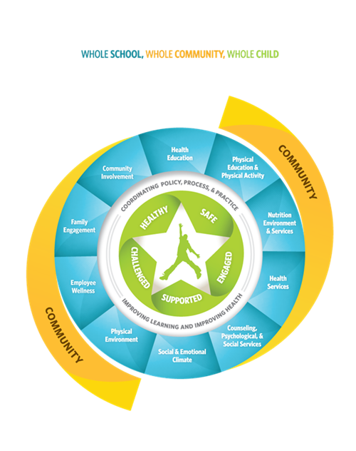

**FBISD SHAC GOALS**

**In the 2023-2024 the Fort Bend Independent School District School Health Advisory Council (SHAC) will:**

1. Develop a process for SHAC to provide input on Board adopted Legislative Priorities.

2. Increase support and awareness of Student Wellness Committees & recognition of their sponsors.

3. Ensure Campus Improvement Plans include wellness strategies created by their Campus Wellness Committee.

4. Develop a process for the district to provide families with gun safety and storage information.

5. Recommend expansion of Action Based Learning Labs and including movement in classrooms (all levels).

6. Expand District level mental health supports available to ALL students.



For more information, please contact Allison Thummel, SHAC Chair, at [chairfortbendisdshac@gmail.com](mailto:chairfortbendisdshac@gmail.com)